**Business Math Week 2 Quiz**

**1. (2 pts)**

Find the equation (in terms of $x$) of the line through the points (-3,5) and (2,-10)

$y=$

**2. (2 pts)**

Last year, Pinwheel Industries introduced a new toy. It cost $ $1900$ to develop the toy and $ $30$ to manufacture each toy. Fill in the blanks below as appropriate.  
  
 A.) Give a linear equation in the form $C=mx+b$ that gives the total cost, $C$, to produce $x$ of these toys: $C=$ 
    
  
 B.) The total cost to produce $n=1350$ toys is $\$$.  
  
 C.) With $\$$ $76900$, a total of  toys can be produced.

**3. (2 pts)**

Sketch a graph of $f\left(x\right)=-\frac{1}{2}x+1$

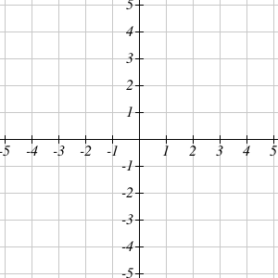

**4. (2 pts)**

Find the point at which the line $f\left(x\right)=-x+5$ intersects the line $g\left(x\right)=2x-1$  
  
Give your answer as coordinates of the point in the xy-plane ( , )

**5. (2 pts)**

You decide to begin selling light sabers at the local carnival. Your cost for each light saber is $1.25 plus you have to pay a fixed weekly fee of $130 for the booth. Your plan is to sell each light saber for $2.75.

1. Write a function, $C\left(n\right)$ , to represent your total costs for the week if you sell $n$ light sabers. $C\left(n\right)=$
2. Write a function, $R\left(n\right)$ , to represent the revenue from the sale of $n$ light sabers during the week. $R\left(n\right)=$
3. Write a function, $P\left(n\right)$ , that represents the profits for selling $n$ light sabers in a given week. $P\left(n\right)=$
4. How many items must you sell to break even?  
    light sabers

**6. (2 pts)**

Suppose the quantity demanded, *q*, of a product when the price is *p* dollars is given by the equation $p=624-6q$   , and the quantity supplied is given by the equation $p=2q$   .  Find the equilibrium price and quantity.

Equilibrium quantity:   items

Equilibrium price:  $

**7. (2 pts)**

|  |  |
| --- | --- |
| Function Notation, Graphs, Ordered Pairs, Tables | |
| *The function $g\left(x\right)$ is graphed below.* ***Rewrite the points*** *on the graph in table and using function notation. Your x's should be in order from least to greatest.* | |
| **Graph**  Graphs |  |
| **Table**   |  |  | | --- | --- | |  |  | |  |  | |  |  | |  |  | |  |  | |  |  | |
| **List the points as $g\left(x\right)=y$**  Example: (0,0) gets written as g(0)=0 |

**8. (2 pts)**

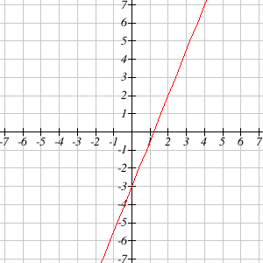  
Two points on this line are (0, -3) and (2, 2)

Find the values of m and b for this line. $m=$ $b=$
  
   
  
   
  
Enter your answers as integers, fractions, or decimals.

**9. (2 pts)**

Given the points $\left(-8,1\right)$ and $\left(0,1\right)$ on a line, find the equation of the line. $y=$

**10. (2 pts)**

Find the slope of the line given its graph. Enter your answer as an integer or a reduced fraction.  
  
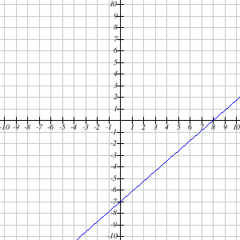  
  
Slope =  